**Milestone 2: Group 51 – Ishayu Ray, Kyle Kirejczyk, Kunal Bagga, Eric Asante**

**Link to Figma Personas:** [**https://www.figma.com/board/x6IWnyMA2li9yipEavPLIk/Group-51---Milestone-2?node-id=0-1&t=GuLrgVApOvZmeFz6-1**](https://www.figma.com/board/x6IWnyMA2li9yipEavPLIk/Group-51---Milestone-2?node-id=0-1&t=GuLrgVApOvZmeFz6-1)

**Project Board**

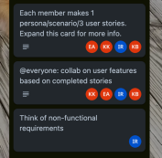

**Personas, User Stories, & Scenarios (on next page)**

Kyle:

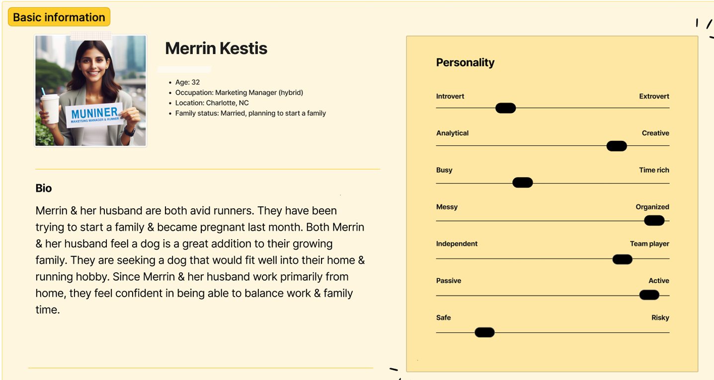

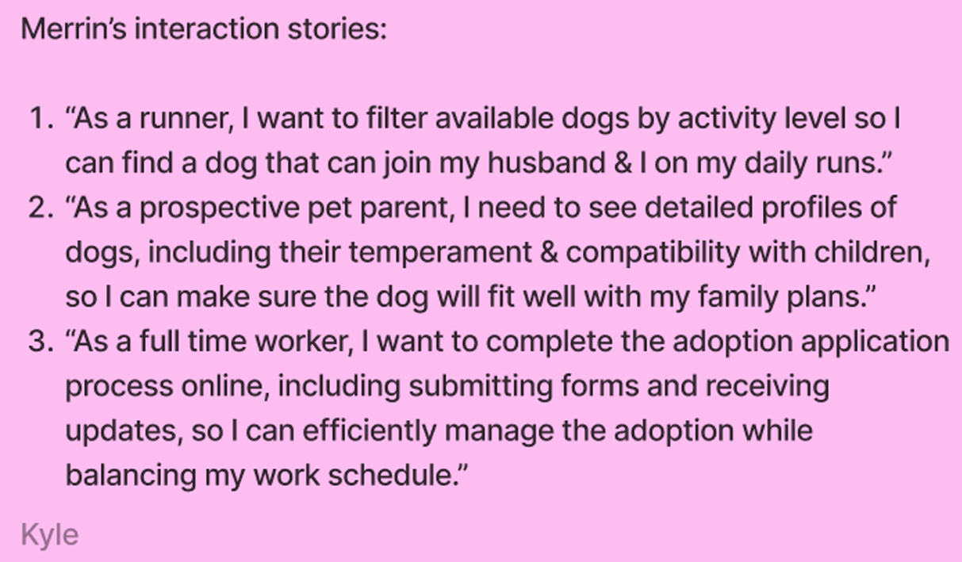

**Scenario:** Merrin and her husband log onto the pet adoption platform after hearing about its user-friendly interface. They start by filtering dogs based on energy levels and family compatibility since they’re expecting a baby. After browsing several profiles, they find a playful Labrador Retriever that fits their activity level. They read through testimonials from other families who adopted similar dogs, which reassures them about their decision. Excited about their potential new family member, they fill out the online adoption application and look forward to meeting the dog in person.

Ishayu:

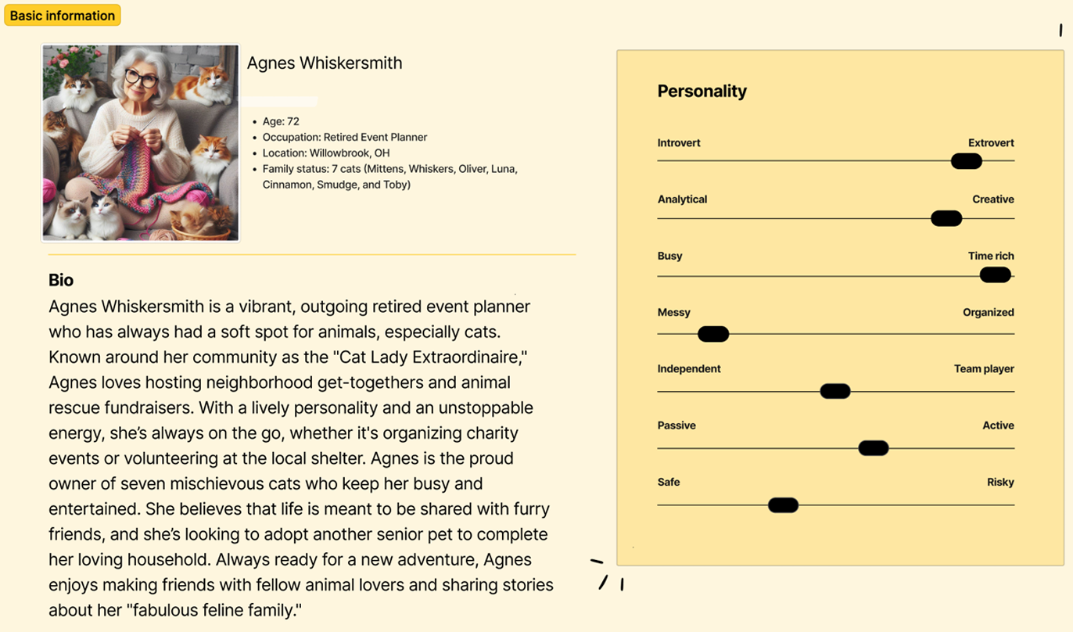

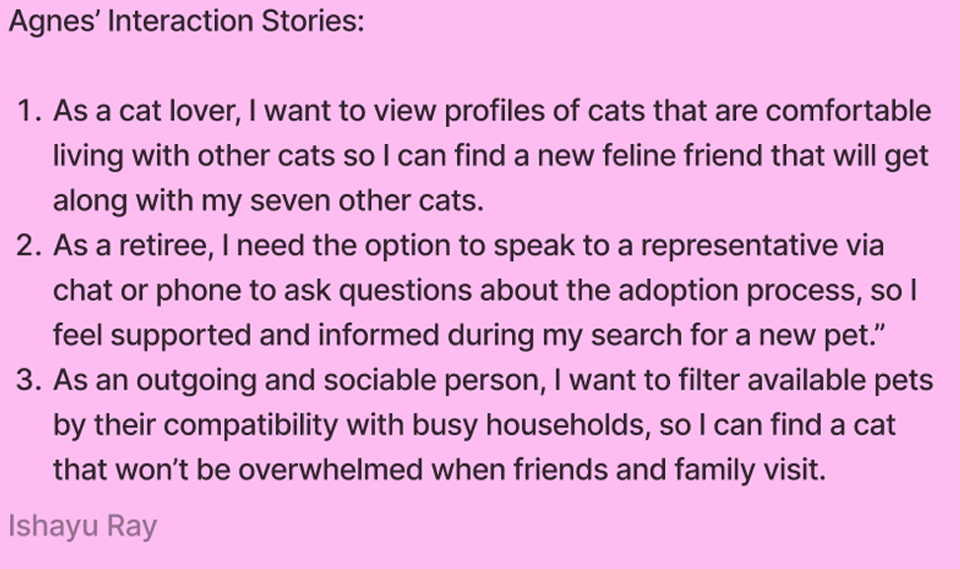

**Scenario:** Agnes, after hearing about the pet adoption platform from her cat-loving friends, decides it’s time to welcome a dog into her lively household of seven cats. Excited about the new adventure, she logs into the platform and uses the temperament filter to find a dog that would be calm and tolerant of cats. She stumbles upon an affectionate mixed-breed dog with glowing reviews about its easy-going nature around other pets. Intrigued, Agnes instantly imagines the new pup lounging alongside her cats. With a few clicks, she completes the application, all while thinking about how she’ll introduce the dog to her “fur family.” She eagerly awaits the home visit, excited for the new addition to her bustling, quirky household.

Eric:

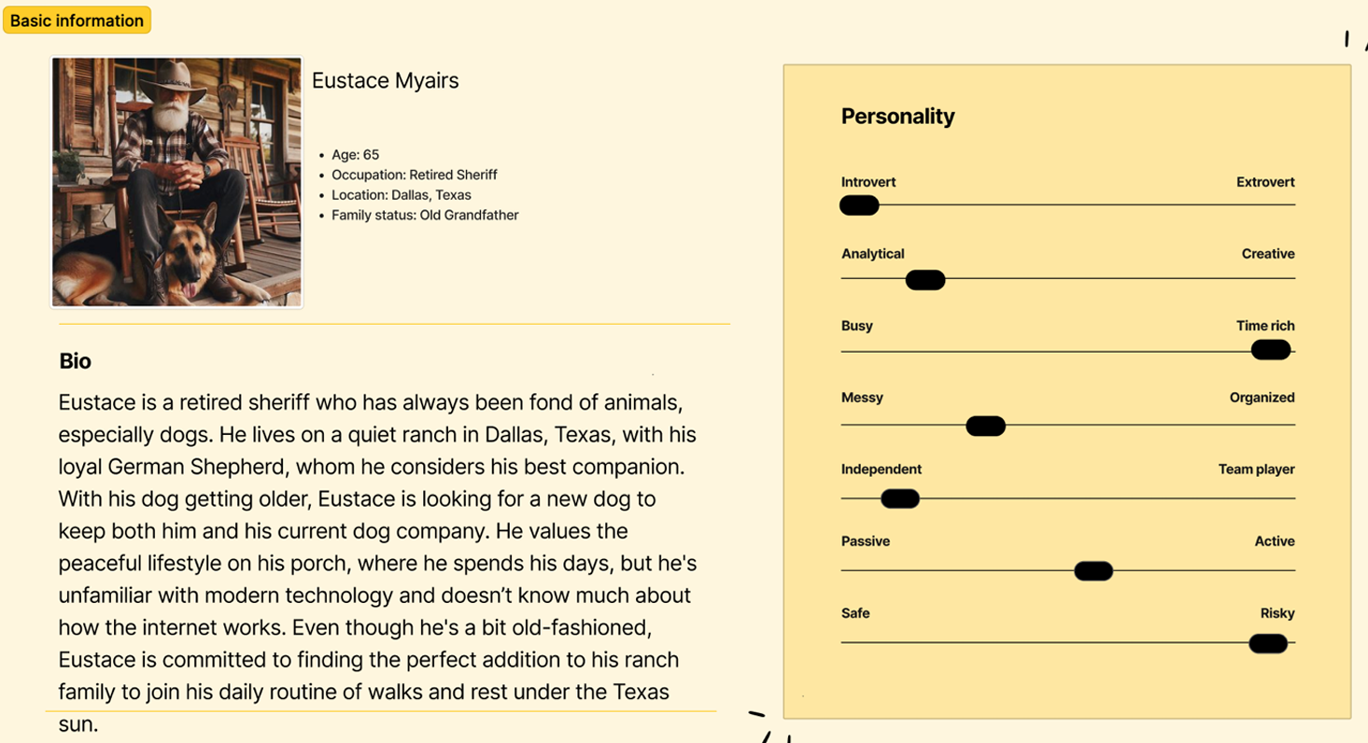

**Scenario:** Eustace, sitting on his porch with his 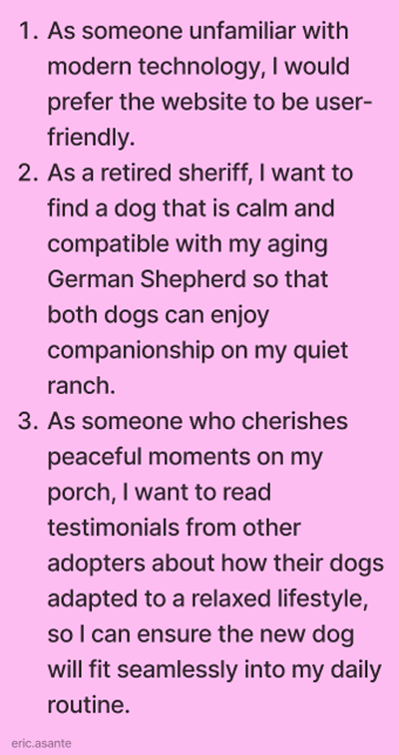

loyal German Shepherd by his side, decides it’s

time to find a new companion for his dog. He’s

hesitant about using the computer but seeks help

from his granddaughter, who guides him through

the adoption platform. Together, they filter the

options for dogs that are low-maintenance and

known for being good with older dogs. Eustace

finds a gentle golden retriever that seems perfect

for his ranch lifestyle. With his granddaughter's

assistance, he fills out the adoption application

and sets up a visit to meet the dog, eager to find a

new friend to enjoy quiet days under the Texas sun.

Kunal:

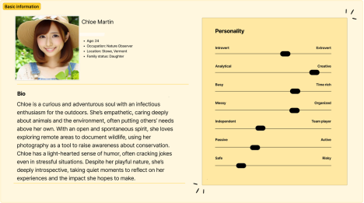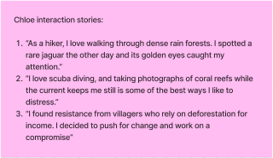

Chloe, fueled by her passion for wildlife conservation, visits the adoption platform to find a new canine companion. She uses the filter options to search for dogs that are known for their friendly nature and energy level to match her adventurous lifestyle. After reviewing several profiles, she finds an energetic border collie that not only fits her personality but also has a history of being great with other animals. Chloe schedules a meet-and-greet at a local park, where she brings her camera to document the experience. She’s excited to capture moments of the dog’s playful personality while considering how they can work together on future conservation projects.

**Requirements:**

1. Usability

o The application must be user-friendly and accessible, ensuring ease of navigation for all users.

o User interface designs should be visually appealing and intuitive.

2. Security

o User data must be stored securely, with encryption for sensitive information.

o Implement secure authentication methods (e.g., password hashing, session management).

3. Performance

o The application should load quickly and respond promptly to user interactions.

o Optimize images and resources for better performance.

4. Compatibility

o The web application must be compatible with major web browsers (Chrome, Firefox, Safari, Edge) and mobile devices.

o The layout should be responsive to accommodate various screen sizes.

5. Scalability

o The application should be designed to handle an increasing number of users and pets without significant performance degradation.

6. Maintenance

o Code should be well-documented for easy maintenance and updates.

o A clear process for bug tracking and feature requests should be established.

**Features**

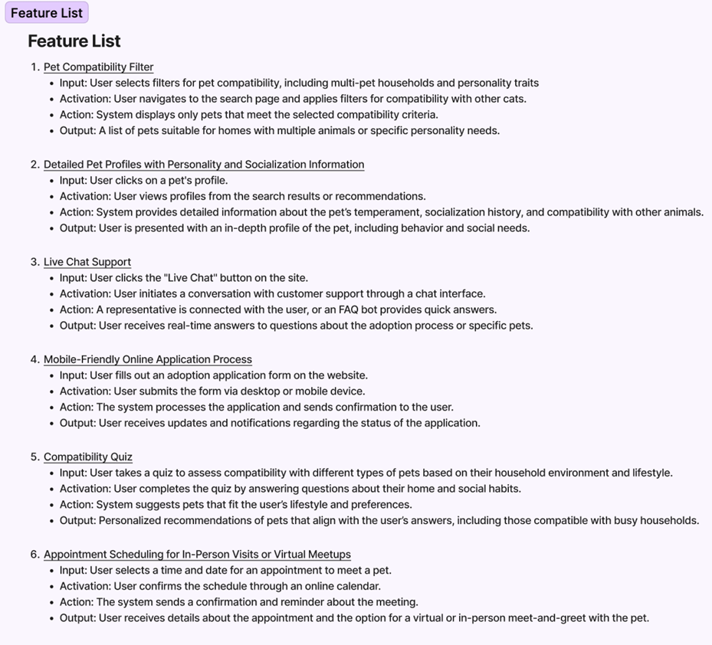**Additional Info about Users (next page)**

